ANNUAL REPORT ON ACTIVITIES AND FIANCIAL
MANAGEMENT OF THE 2018

SLOVAK ANTI-DOPING AGENCY

Prepared in accordance with Section 86 (4) (o) of the Act No. 440/2015 Coll. on Sport and on amendments and supplements of certain acts, as amended.

Table of contents
2

1. Information on Changes to Agency Regulations 3
2. Information about bodies, their changes and activities 4
3. SADA´s activities in 2018 - assessment 10
4. Assessment of the annual doping control plan for the previous year 22
5. Annual Financial Statements 23
6. Summary of revenues and expenditures 25

Annex 1 Balance sheet
Annex 2 Profit and loss statement
Annex 3 Notes

Information on Changes to Agency Regulations
3

2018 saw the following changes to SADA´s internal regulations:
  - Assessment of the impact on SADA´s personal data protection (GDPR, personal data protection, processing operation, risk assessment, risk elimination); Qualitative analysis of SADA´s security risks - together with a table, effective from 25 May 2018.
  - SM05 Regulation on using SADA´s company motor vehicles amended as follows: a work position of an employee responsible for maintenance and operation of motor vehicles was created, effective from 1 July 2018, a provision on using private vehicles for work-related purposes and taxi services was added, effective from 1 July 2018, the provisions on using company motor vehicles for private purposes was cancelled, effective from 1 July 2018, obligations of users of company motor vehicles were established, effective from 1 July 2018, and PHM consumption standards were added, effective from 1 July 2018.
  - SM11 Regulation on arranging foreign business trips, foreign business visits and certain activities related to international relations in SADA amended as follows: the process for administrative arrangement, accounting and billing SADA´s foreign business trips was specified in more detail, effective from 18 July 2018.
  - P 01 Rules of Organization were amended as follows: the position of a GDPR officer was added, effective from 1 September 2018, a Department of Economy and Support Activities was established, effective from 1 September 2018, the position of a Testing and Prevention Department Manager was created, effective from 1 September 2018, a Testing Department was established, effective from 1 September 2018, a Prevention Department was established, effective from 1 September 2018, and a new SADA organizational structure was created (Annex 1 to the P 01 Rules of Organization), effective from 1 September 2018.
  - SM 06 Regulation on addressing the motions related to reporting anti-social activities in SADA, effective from 1 October 2018.

4

Information about bodies, their changes and activities

Organisation name: ANTIDOPINGOVÁ AGENTÚRA SLOVENSKEJ REPUBLIKY / SLOVAK ANTI-DOPING AGENCY

(hereinafter referred to as "SADA")

Statutory representative: PaedDr. Žaneta Csáderová, PhD., Managing Director

Legal form: State contributory organisation connected with its financial relationships to the budget of the Ministry of Education, Science, Research and Sport of the Slovak Republic.

Establishment: 1 January 2009 in accordance with Section 6 (1) of the Act

No. 300/2008 Coll. on Organization and Support of Sports and on amendments and supplements of certain acts.

The Act No. 440/2015 on Sport and on amendments and supplements of certain acts
which came into effect on 1 January 2016 grants it a status of a
state contributory organisation established by law as an independent organisation performing doping prevention and control activities in the Slovak Republic.

Company ID No: 50 119 231

Registered office: Hanulova 5/C, 841 01 Bratislava

Postal address: Antidopingová agentúra SR

P. O. BOX 5

840 11 Bratislava 411

Contact data: Phone No: +421 2/44 64 34 11

www.antidoping.sk

E-mail: office@antidoping.sk

5

SADA´s organisational structure
SADA´s organisational structure is laid down in the SADA Statute No. 2016-9381/3493:1-56AA and in the SADA´s Rules of Organisation P 01 valid since 1 September 2018.

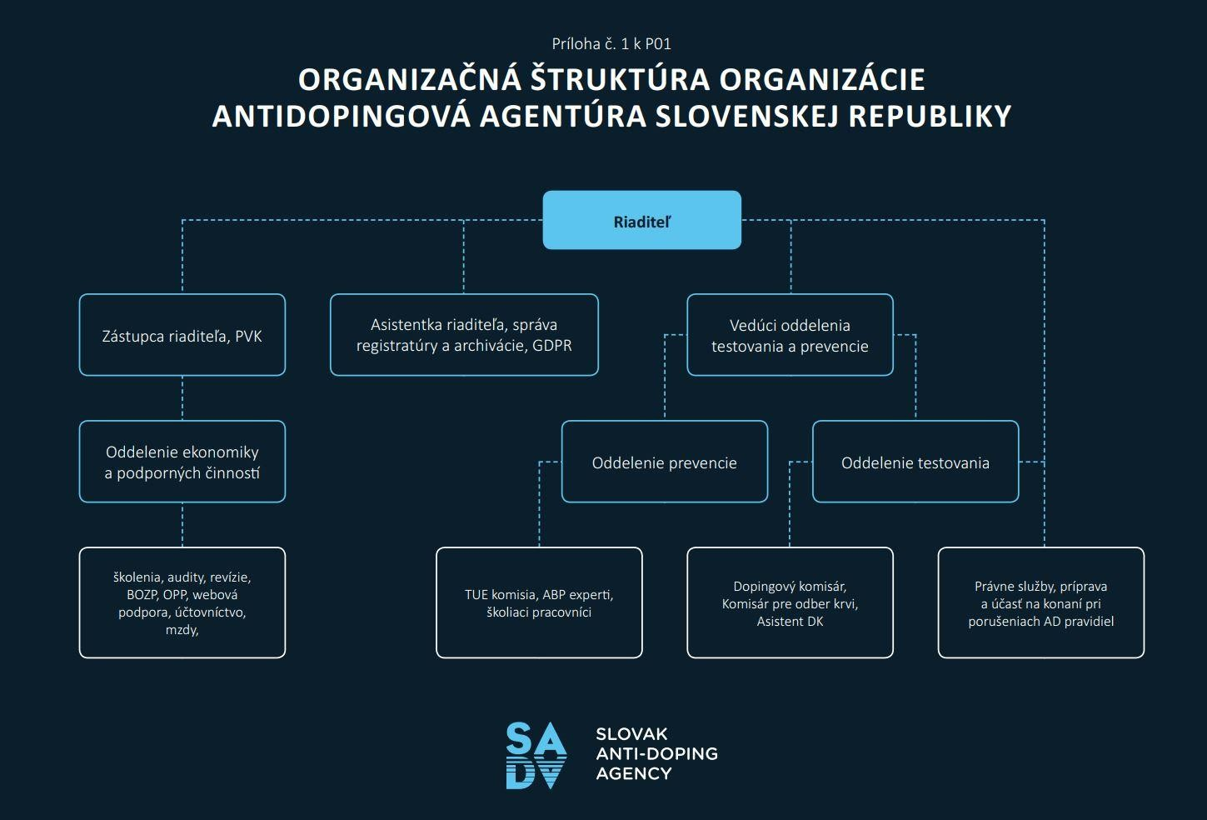

CSÁDEROVÁ Žaneta, Mgr., PhD. | Managing Director
Čambal Ladislav, Ing. | Deputy Managing Director / PVK
HORVÁTHOVÁ Slavomíra, Mgr. et Mgr. | Managing Director´s assistant, expert for registry and archiving administration, GDPR
KOLIBÁŠOVÁ Viera | Economist
BANÍK Ján, Mgr. | Expert for testing and investigation
TOLDY Andrej, Mgr. | Administrative officer
HAULIŠOVÁ Soňa, Mgr. | Expert for the National Registered Testing Pool and ADAMS
PAGÁČ Tomáš, Ing. PhD. (part-time) | Expert for prevention and TUEs
JEŽÍKOVÁ Zuzana, Ing. (part-time until 4 May 2018) | Education expert
GULÁN Ľubomír, MUDr. | Testing and Prevention Department Manager / Education expert
ŠTALMACHOVÁ Barbora, Mgr. (on maternity leave since 10 November 2013)
External employees (as sport experts) | 26 doping control officers (DCOs)

6

The position of SADA in the Slovak Republic is defined by basic documents laying down the roles of the organisation at the national level:
- Act No. 440/2015 Coll. on Sport and on amendments and supplements of certain acts, as amended (hereinafter referred to as the "Act").
- SADA Statute - in accordance with Section 86 (6) of the Act No. 440/2015, the Ministry of Education, Science, Research and Sport of the Slovak Republic issued the Statute under the No. 2016-9381/3493:1-56AA, effective since
  - February 2016. As referred to in the Statute, SADA is a legal entity which acts in its own name in legal relationships, acquires rights, undertakes commitments and has the liability resulting from such relationships.
An Act which came into effect on 1 January 2016 changes the SADA´s position. With regard to the need to enhance the degree of its independence (resulting from the World Anti-Doping Code), it is granted a status of a contributory organisation established by law as an independent organisation which performs doping prevention and control activities in the Slovak Republic. In accordance with model rules of the World Anti-Doping Agency, the personal extent of the scope of action of the Agency is modified as well. In addition to the legislative regulation of its position, it needs to meet certain qualitative parameters of its activities. They are based on the organizational structure of the organisation, i.e. on the organizational, work and registry rules and plan. As for doping control processes and granting TUEs, SADA complies with the Quality Certificate in accordance with the Slovak Technical Standard EN ISO 9001:2015.
SADA´s main goal is to perform the tasks laid down in the Act on Sport. They include mainly performance of preventive anti-doping measures in sport on the basis of cooperation with WADA and with international anti-doping organisations. SADA cooperates with international sports federations and national sports federations, in particular when coordinating and performing doping control in sports, mainly at the top professional and performance level. Such irreplaceable mission results also from adoption and implementation of international contracts and conventions signed by the Slovak Republic. An important part of the SADA´s mission is also to ensure continuous education of selected target groups of sportsmen and overall educational activities in this area.
In 2018, SADA concluded Memorandums of Cooperation with the Faculty of Sport of the Prešov University in Prešov, the Faculty of Physical Education and Sports and the Faculty of Pharmacy of the Comenius University in Bratislava, the Military Sport Centre Dukla Banská Bystrica, the Police Sport Centre of the Ministry of Interior of SR and with Be Cool, spol. s.r.o.
In 2018, SADA also signed international agreements with the Russian Anti-Doping Agency (RUSADA), Union Cycliste Internationale (UCI) and it became a partner of the Erasmus+ project (EU programme for education, expert preparation, youth and sport).

Description of activities of the Slovak Anti-Doping Agency for 2018
7

- Performing preventive measures aimed at combating doping in sports

This task involves raising awareness of the rights and obligations of sportsmen and other users which the Slovak Republic has undertaken to perform by signing international anti-doping sports contracts and conventions. One of its forms is to disclose long-term information (World Anti-
Doping Code, its international standards, etc.) and methodological procedures for ADAMS users. It supports anti-doping research and education. Other forms include publishing educational materials, holding lectures, seminars, expert discussions, etc. For this purpose, www.antidoping.sk will be updated regularly. An important mission of the Slovak Anti-Doping Agency is to provide information, perform educational, advisory and awareness-raising activities for children and youth, in particular for pupils and students of sports schools and sports classes, parents as well as for the sporting public. It involves publishing information and methodological materials and holding interactive presentations in selected target groups and in cooperation with expert organisations and civil associations.

Person in charge: | Education expert
Sponsor: | Ľubomír Gulán
Goals: | Consolidation of moral and ethical values of the sporting population in relation to combating doping in sports, ensuring performance of tasks of the World Anti-Doping Programme

- International cooperation related to combating doping in sports (in particular with the World Anti-Doping Agency,
anti-doping agencies in other countries and international sports
organisations)

An exact specification of deadlines and costs of performance of the above-mentioned task results from the disclosed deadlines and venues of sessions of individual international organisations. Involvement in organisations: World Anti-Doping Agency (WADA), Institute of National Anti-Doping
Organisations (INADO), Anti-Doping Convention of the Council of Europe (TDO and CAHAMA). Working groups of the Council of Europe TDO-LI, TDO-EDU, TDO-SCI, European Commission, seminar of the doping control laboratory in Seibersdorf, bilateral and multilateral meetings with national anti-doping organisations of EU member states.

Person in charge: | Managing Director, employees authorized by the Managing Director and authorized members of advisory bodies
Sponsor: | Žaneta Csáderová
Goals: | Cooperation with the World Anti-Doping Agency and other anti-doping organisations, performing tasks resulting from the Anti-Doping Convention of the Council of Europe and from the UNESCO Anti-Doping Convention.

8

- National cooperation in relation to combating doping in sports (in particular with national sports federations,
the Slovak Olympic Committee, the Slovak Paralympic Committee and
other
organisations)

Close cooperation at this level is a necessary part of combating doping in sports. This involves coordination of doping controls, transfer of information about stays and plans of sportsmen and teams representing the Slovak Republic. Last but not least, it is the need to provide information and to coordinate in the event of any positive doping findings of Slovak sportsmen and also of foreign sportsmen tested during competitions held in the Slovak Republic. It maintains the National Registered Testing Pool. Checking incorporation of and compliance with rules of the World Anti-Doping Programme. This task involves also co-organizing seminars, conferences and other educational events with the above-mentioned entities.

Person in charge: | expert for the National Registered Testing Pool and ADAMS and expert for testing and investigation
Sponsor: | Soňa Haulišová, Ján Baník
Goals: | Incorporation of and compliance with rules of the World Anti-Doping Programme by sports federations and sports organisations.

- Performing, organising and managing doping controls, analysing samples collected for doping
control purposes, preparing an annual doping control plan, informing of valid decisions in the
matter of violation of anti-doping rules of the World Anti-Doping
Agency, entering into agreements on reciprocal testing in accordance with the World Anti-Doping
Programme

Person in charge: | expert for testing and investigation, expert for the National Registered Testing Pool and ADAMS
Sponsor: | Ján Baník, Soňa Haulišová
Goals: | 300 collections of biological material

- Informing of changes to the list of prohibited substances and prohibited methods, granting
TUEs

From the point of view of the World Anti-Doping Code, such activities are necessary particularly for sportsmen with different health problems and diseases. Such activities include also activities of the TUE Committee. It provides consultancy with regard to medicines and medicinal
preparations and administers a database of prohibited and permitted medicines and medicinal preparations for anti-doping purposes. It maintains and updates an information system for verifying prohibited substances.

Person in charge: | expert for prevention and therapeutic use exemptions (TUEs)
Sponsor: | Tomáš Pagáč
Goals: | Enable sportsmen to use prohibited substances/methods for therapeutic purposes. Provide expert information regarding medicines and medicinal preparations containing or not containing prohibited substances.

- Educating anti-doping sports experts
9

The crucial activity here is organization of the annual seminar for DCOs where new information about combat of doping in sports or some legal and health aspects are provided; there is also a room for sharing information and experience, what enhances the quality of activities of all participants. Another activity focuses on selection and preparation of new DCOs.

Person in charge: | expert for testing and investigation and education expert
Sponsor: | Ján Baník, Ľubomír Gulán
Goals: | Ensuring a sufficient number of DCOs to perform tasks of the World Anti-Doping Programme.

- Common operation and other services

The Slovak Anti-Doping Agency does not own any residential or non-residential premises. SADA resides in the premises of the Statistical Office of SR free of charge based on a Contract on Borrowing Non-Residential Premises. Flat operating costs include all services related to the use of the borrowed premises, e.g. costs of protection of the building, power supply, waste disposal, cleaning, energy, water and sewage, etc. and they are determined as flat fees for office spaces and an aliquot part of common spaces. Special legal and advisory services, GDPR, telecommunication and postal services, costs of economic services and costs of ensuring the organization´s operation represent a significant part of the costs.

Person in charge: | economist, administrative officer, expert for external relationships
Sponsor: | Viera Kolibášová, Andrej Toldy
Goals: | Efficient, economical and purposeful use of funds of the Slovak Anti-Doping Agency, of the state property it administers and compliance with financial limits according to the organisation´s budget

- Performing the required doping controls

Person in charge: | economist, administrative officer, expert for testing and investigation
Sponsor: | Viera Kolibášová, Andrej Toldy, Ján Baník
Goals: | Efficient and economical use of funds of the Slovak Anti-Doping Agency, of the state property it administers and compliance with financial limits according to the organisation´s budget

SADA´s activities in 2018 - assessment
10

SADA´s roles are defined in its basic documents and in the Contract No. 0190/2018 entered into between the Ministry of Education, Science, Research and Sport of the SR and SADA in Bratislava dated 27 February 2018. The Contract is available on www.antidoping.sk.

SUMMARY OF THE DOPING CONTROLS PERFORMED

In 2018, SADA continued to follow the international technical standard TDSSA as a part of which a minimum number of additional analyses are performed based on the division of sports and sports disciplines. The main goal in 2018 was out-of-competition testing of professional sportsmen before the upcoming Olympic Games in Pyeongchang, in-competition and out-of-competition testing of high-risk sports as well as national and international cooperation with sports associations and federations.

In 2018, SADA performed 504 doping controls out of which 318 were conducted on the initiative of SADA and 186 were conducted on the initiative of international sports federations.

URINE SAMPLE COLLECTIONS CONDUCTED ON THE INITIATIVE OF SADA

In 2018, SADA performed 318 urine sample collections on its own initiative; other 186 urine sample collections were performed in cooperation with both national and international sports associations, at national, European or global events; altogether it amounts to 504 urine sample collections. Compared to 2017, SADA performed by 2.5% more urine sample collections on its initiative, while the number of ordered urine sample collections dropped by 22.8%.

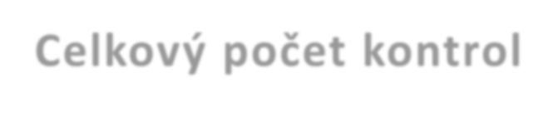
Total number of controls
600
500
551
508 504
400
300
200
100
0
311
197
310
241
318
186

The number of sample collections conducted on the initiative of SADA increased by 2.5%

The number of ordered 22.8%
sample collections dropped by
 | 2016 | 2017 | 2018
Total | 508 | 551 | 504
SADA | 311 | 310 | 318
Ordered controls | 197 | 241 | 186

11

Urine sample collections conducted on the initiative of SADA may be divided into in-competition or out-of-competition sample collections. In 2016, the number of out-of-competition sample collections represented 57% of the total number of sample collections; in 2017, as much as 73% of urine samples were collected outside the competition period. In 2018, the SADA´s goal was to adjust the proportion of out-of-competition and in-competition sample collections to 60:40. Having conducted 164 out-of-competition urine sample collections and 154 in-competition urine sample collection we achieved the proportion of 52:48.
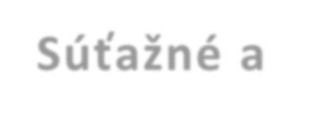
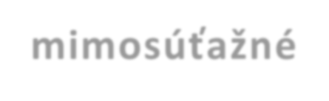
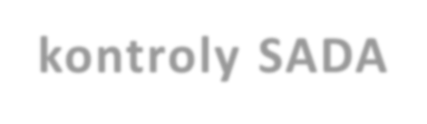
SADA´s in-competition
and out-of-competition controls
350
300
250
200
150
100
50
0
187
164
226

139
154
84

 | 2016 | 2017 | 2018
out-of-competition control | 187 | 226 | 164
in-competition control | 139 | 84 | 154

in-competition
control
48%
out-of-competition
control
52%

In 2018, SADA performed 318 urine sample collections out of which 164 were out-of-competition sample collections and 154 were in-competition sample collections.

SADA performed the highest number of sample collections in the following sports: Sample collections ordered by SADA were performed in individual sports as follows:

 | Sport | Total | In-competition sample collection | Out-of-competition sample collection
1 | athletics | 43 | 21 | 20
2 | canoe sprint | 29 | 14 | 15
3 | body-building and fitness | 24 | 16 | 8
4 | swimming | 21 | 15 | 6
5 | ice hockey | 19 | 7 | 12
6 | handball | 18 | 12 | 6
7 | basketball | 17 | 10 | 7
8 | weightlifting | 15 | 6 | 9
9 | wrestling | 14 | 6 | 8
10 | biathlon | 14 | 0 | 14

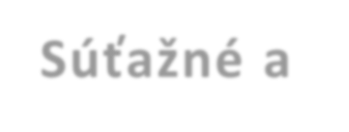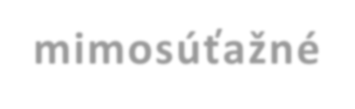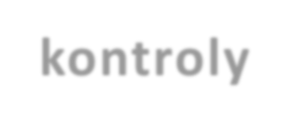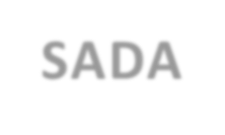
12
SADA´s in-competition and out-of-competition
controls
50
45
40
35
30
25
20
15
10
5
0
43
29
24
21 20 21
14 15
16
19
15
18
17
15
14
8
6
12
7
12
6
10 7
6 9
14 14
6 8 0
Total
In-competition sample collection
Out-of-competition sample collection

SUPPLEMENTARY (ESAS, GHRFS) AND ADDITIONAL (SPC) ANALYSES OF COLLECTED SAMPLES

Year | ESAs | GHRFs | SPC
2014 | 0 | 0 | 4
2015 | 31 | 27 | 23
2016 | 94 | 75 | 9
2017 | 85 | 55 | 9
2018 | 80 | 61 | 14

In 2015, the above-stated TDSSA standard entered into force according to which it is necessary to perform EPO analyses (ESAs), analyses of the growth hormone from the blood and its factors from the urine (GHRFs). In 2017, SADA met all requirements of the TDSSA in all disciplines with
the exception of the number of analyses to identify the growth hormone from the blood since the obligation started only in 2018. Additional "SPC" (steroid profile confirmation) analyses
needed to be performed at a laboratory request if any sample demonstrated non-standard features of the steroid component. However, none of such tests has confirmed presence of prohibited substances. SADA is responsible for compliance with such standard only for doping controls in relation to which it is the authorizing organisation, based on what at least the minimum number of additional analyses was achieved from the point of view of individual sports and disciplines.

In 2018, SADA performed 80 ESA analyses, 61 GHRFs analyses and 14 additional SPC analyses.

13

BLOOD SAMPLE COLLECTIONS
In the past years SADA was preparing for introduction of blood sample collections and creating a platform for gradual profiling of a haematological module of Athlete Biological Passports (ABPs). In 2018, SADA fully launched blood sample collecting and performed 40 sample collections for ABPs and 74 blood sample collections for growth hormone (GH) analysis. Compared to 2017, it is a fivefold increase in the number of blood sample collections. The aim for 2019 is to maintain the number of blood sample collections as well as to build and continuously add information in ABPs of selected sportsmen.

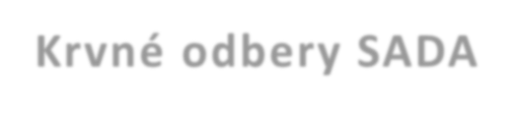
fivefold increase in the number of blood sample collections for ABPs
2015
2016
2017
2018
APB
0
0
8
40
GH
2
12
14
74
SADA blood sample collections
80
60
40
74
20
0
40
0 2
0 12
8 14

fivefold increase in the number of blood sample collections for the growth hormone

 | 2015 | 2016 | 2017 | 2018
APB | 4 | 13 | 39 | 2
GH | 0 | 0 | 5 | 11

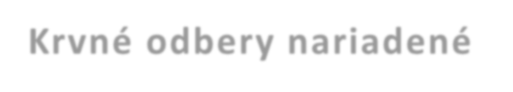
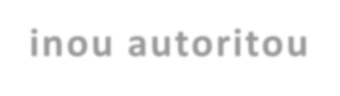
VIOLATIONS OF ANTI-DOPING RULES
Blood sample collections
ordered by a different authority
50
40
30
20
10
0
39
4 0
13 0
5
2 11

Since all violations of anti-doping rules in 2018 are related to body-building and natural body-building, it is our recommendation to increase the number of doping controls as well as to introduce systematic anti-doping education.

In 2018, SADA identified 7 cases of using prohibited substances; 2 cases of violation of anti-doping rules were of a non-analytical nature. All violations were seen in body-building or in natural body-building. From the point of view of use of prohibited substances, S1 group substances - anabolic agents - are used most often; followed by S6 group substances. 8 out of 9 identified cases of violation of anti-doping rules occurred at one event of the Slovak Association of Fitness, Body-Building and Powerlifting, one case at an event of the Slovak Natural Body-Building Association. All cases identified in 2018 have already been concluded.

Year | Number of violations of anti-doping rules
2014 | 10
2015 | 8
2016 | 7
2017 | 11
2018 | 9

14

ADAMS

ADAMS (Anti-Doping Administration and Management System) is an internet database system created by the World Anti-Doping Agency (WADA). It enables to enter, store, share and provide information about individual sportsmen and places of their stay, doping controls, therapeutic use exemptions (TUEs) and any potential sanctions imposed on sportsmen.

ADAMS STATISTICAL DATA

The Agency continuously updates the National Registered Testing Pool in which 48 sportsmen from 18 sports associations and federations are included in cooperation with national sports federations as at the end of 2017; out of them 34 sportsmen on the basis of the National Registered Testing Pool (NRTP) and 14 sportsmen on the basis of the International Registered Testing Pool (IRTP). The basic testing pool currently contains 48 sportsmen.
Out of the total number of sports federations, 15 sports federations cover Olympic and Paralympic sports. Summer Olympic sports are covered by 10 sports federations, winter Olympic sports are covered by 3 sports federations and Paralympic sports are covered by 2 sports federations.
In February 2018, 23rd Winter Olympic Games and 12th Paralympic Games were held in Pyongyang, South Korea. Those sportsmen who participated in the Winter Olympic Games or the Winter Paralympic Games in 2018 (and are not included in the National Registered Testing Pool) were temporarily included in ADAMS until the Games ended. 44 sportsmen were temporarily included in ADAMS for the above-stated reason in the monitored period.

Quarter | NRTP | IRTP | Total
Q1 | 36 | 16 | 52
Q2 | 36 | 14 | 50
Q3 | 34 | 14 | 48
Q4 | 34 | 14 | 48

In 4Q 2017, new criteria were created for including sportsmen in the National Registered Testing Pool and in ADAMS. Based on the new criteria for including sportsmen in the National Registered Testing Pool and in ADAMS and on the basis of selection of sportsmen according to risk factors, the Agency was gradually decreasing the number of included sportsmen. The total number of sportsmen in 4Q 2018 represents a drop by 23.8% compared to 4Q 2017.
The number was decreased following WADA´s recommendations. Every sportsman included in ADAMS must undergo at least three sample collections per year. With the high number of sportsmen, SADA does not have sufficient funds and staff to comply with such regulation.

15
NRTP
350
300
36
250
200
150
281
36
34
100
50
123
126
0
Q1
Q2
Q3
34
39
Q4
2017 2018

WARNINGS AND MISSED TESTS

In view of the above-stated regulation, 13 warnings were issued for violation of anti-doping rules as a result of failures to enter data in ADAMS and missed tests.
With regard to the gradual decrease in the number of sportsmen in the National Registered Testing Pool, the number of warnings issued for violation of anti-doping rules - for failures to fill in or for incorrectly filled in data about the place of stay in ADAMS - decreased as well.

Filing Failure
50
40
30
20
10
0
45
24
2015 2016
2
2017
1
2018
Filing Failure
One warning was issued for a failure to enter data in ADAMS and it was assessed as a violation of anti-doping rules. First warning out of the total of three potential violations of the anti-doping rule was issued for the sportsman (athletics). With regard to that, the Agency requested a written explanation of the violation of the above-stated rule, undergoing a Triagonal e-learning course and urgent entry of all necessary information about the place of stay in ADAMS required for conducting any potential out-of-competition doping controls.

With regard to the gradual decrease in the number of sportsmen in the National Registered Testing Pool, the number of warnings issued for violation of anti-doping rules - for failures to provide the required information about any change of the place of stay / missing the testing - increased. With the lower number of sportsmen in NRTP the Agency could conduct more out-of-competition controls per sportsman (the effort to conduct the required three controls per sportsman annually); however, this led to an increase in the number of missed tests.

16
Missed Test
20
19
15
14
12
10
5
6
0
2015
2016
2017
2018
Missed Test

12 warnings were issued for missed tests, out of that 2 warnings were annulled following SADA´s decisions, and 10 warnings were assessed as violations of anti-doping rules.
First warning out of three possible violations of the anti-doping rule were issued for nine sportsmen (sledding, biathlon, paraskiing, skiing, tennis, box 2 times, canoe sprint, wrestling). With regard to that, the Agency requested a written explanation of the violation of the above-stated rule, undergoing a Triagonal e-learning course and subsequent harmonization of the training schedule (monitoring form regarding the places of stay in ADAMS) and its notification so that any potential future out-of-competition doping control could be conducted without any delays and consequences for sports activities. Second warning out of three potential violations of the anti-doping rule was issued for three sportsman (judo, tennis, weightlifting). With regard to that, the Agency requested a written explanation of the violation of the above-stated rule and subsequent harmonization of the training schedule (monitoring form regarding the places of stay in ADAMS), undergoing a Triagonal e-learning course and a personal meeting at the Agency for the purpose of providing anti-doping and ADAMS retraining.

Missed Test | Sport | Association | P/A
 | sledding | SZS | first violation
 | biathlon | SZB | first violation
 | paraskiing | SPV | first violation
 | skiing | SLA | annulled
 | tennis | STZ | first violation
 | box | SBF | annulled
 | box | SBF | first violation
 | canoe sprint | SK | first violation
 | wrestling | SZZ | first violation
 | judo | SZJ | second violation
 | tennis | STZ | second violation
 | weightlifting | SZV | second violation

GRANTING THERAPEUTIC USE EXEMPTIONS
17

CONSULTANCY

The aim of consultancy activities is to offer a room for questions and answers to sportsmen, mainly in relation to information about prohibited substances or their presence in certain medicines or food supplements. In 2018, the Slovak Anti-Doping Agency provided 142 expert consultations related to drugs and food supplements, representing a 13% increase in the number of consultations compared to 2017.
The drug database project (www.zakazanelatky.sk) continued in 2018 through which sportsmen may search for any drug and check the presence of prohibited substances in it.
With regard to questions related to composition of drugs and their safety from the point of view of doping effects, presence of prohibited substances is assessed very accurately since drugs are subject to strict regulation and information about drug composition is clearly defined. Most consulted medicaments did not contain any prohibited substances; in certain cases we recommended medication change. Most frequently consulted drugs belonged to the groups of antihistamines, antibiotics, glucocorticoids, analgetics and dermatologics.

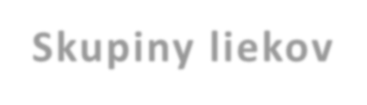
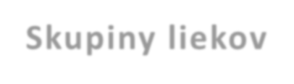
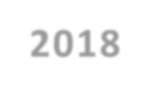
Summary of groups of drugs sent by sportsmen for consultation
Drugs categories 2017
Drugs categories 2018
60%
50%
40%
30%
20%
10%
0%
50%
20%
15%
10%
40%
35%
30%
25%
20%
15%
10%
5%
0%
35%
%
5%

20% 20%
15%
10

Special attention is paid to drugs containing prohibited substances in limited concentrations (beta-2 agonists) which may be used only in limited amounts. Another group includes glucocorticoids which are prohibited only in systemic use in the List of Prohibited Substances 2018.

THERAPEUTIC USE EXEMPTIONS
18

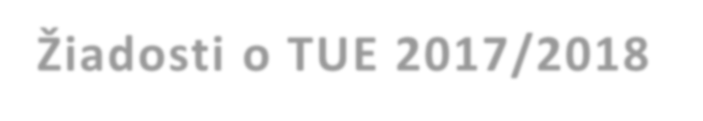
In 2018, SADA did not grant any therapeutic use exemption. All 10 requests for therapeutic use exemptions were rejected since therapeutic use exemptions were not necessary for using the particular drugs.
Requests for TUEs 2017/2018
15
10
5
0
12
10
3
0

 | 2017 | 2018
number of requests for TUEs | 12 | 10
number of granted TUEs | 3 | 0

EDUCATION
An important mission of SADA is to provide information and perform educational, consultancy and awareness-raising activities. It involves publishing printed information and methodological materials, disclosing electronic materials on the Agency´s web page and holding interactive presentations in selected target groups and in cooperation with expert organisations and civil associations.
In April 2018, a reviewed version of the World Anti-Doping Code 2015 entered into force and SADA had to implement new rules in order to be able to continue with the process of setting the anti-doping programme in individual areas.
In 2018, SADA employees participated in representation camps of our sportsmen, summer sports camps as well as events organized by individual sports federations for the public where the anti-doping issue was introduced in an interactive form and they were also focused on building values of clean sports. For children and youth, mainly pupils and students of sports schools and sports classes, educational presentations were organized, promoting the idea of clean sports. They were supported by a new campaign in cooperation with our best sportsmen in the stand-up comedy style with The copyright for using the audio recording for Mr. Dopo video was extended by another year. Use of food supplements is becoming more and more topical also among young sportsmen and SADA prepared an educational video with one of our sportsmen regarding this topic.
SADA has become involved in an international Erasmus research project: ”National Anti-Doping Governance Observer: Benchmarking Governance in National Anti-Doping Organisations (NADGO)“ . Experts cooperated with Doc. Milan Sedliak and the Faculty of Physical Education and Sports of the Comenius University in Bratislava on preparation of university lecture notes about doping. In cooperation with the Academy of the Police Force of SR, they also prepared several chapters about substances with anabolic and other hormonal effects for their educational materials.

19

Altogether 11 lectures and trainings for sportsmen and coaches were organized; we participated in 7 conferences and 3 major events held for the public. In addition, we actively participated in a session of a multi-disciplinary integrated group of experts focused on elimination of drug-related crime.
In 2018, the following events were held with an active involvement of SADA where the total number of participants exceeded 5,000:
26 January 2018 - lecture for ZŠ HC Topoľčany
31 January 2018 - lecture for VK Tatran, Bratislava
27 February 2018 - lecture for the Sports Secondary Grammar School Nitra
5 April 2018 - lecture for SZŠ Nová Dubnica
24 April 2018 - NAKA conference, Bratislava
2 June 2018 - lecture at a session of the medical board of the Slovak Ice Hockey Federation, Žilina
6 June 2018 - "Ivan Stodola Health Education Days" conference, Trnava
22 June 2018 - OLYMPIC DAY, Bratislava
2 July 2018 - lecture - sports camp of SPF, Dudince
11 August 2018 - training for WAKO/kickbox representation, Tatranská Lomnica
19 August 2018 - MADE FOR HEALTH, Bratislava
5 October 2018 - "Psychological preparation and mental coaching in sports" conference, Bratislava 6 October 2018 - SPORTS FESTIVAL Wannado, Bratislava
8 October 2018 - KTL Public Health Night conference, Bratislava 15 October 2018 - training for kickbox at the European Championship in Bratislava
18 October 2018 - MISO DTČ session, Bratislava 23 October 2018 - training of SAZ representation, Štrbské Pleso
25-26 October 2018 - "Sports and Law" conference, Stará Lesná 16 November 2018 - seminar for the Slovak Football Association, Senec
26 November 2018 - Anti-doping Workshop conference, Seibersdorf 1-2 December 2018 - "Physio and Sports" conference, Bratislava
8 December 2018 - training for small football representation, Bratislava

Eight new candidates for the DCO position were trained at the end of the year. Three of the candidates are going to work as assistants in 1Q 2019; other 5 candidates dropped out during the training.
The e-learning project continued in 2018 as well. However, the Contract was terminated in September 2018 and new conditions were agreed upon for the next 2 years. 328 users underwent our course in 2018 and 294 of them also passed the test successfully. With regard to the higher but still small amount of applicants, we asked the World Anti-Doping Agency to provide us with the conditions of using the "ADeL" platform. The price offered by WADA was much higher than the price offered by Triagonal; nonetheless, we agreed that SADA might use ADeL as a backup option in the English version and the education expert had been granted the "national admin" rights. 48 Slovak sportsmen used this opportunity in 2018. At the same time, our staff from the Prevention Department helped translate the e-education module of the International Association of Athletics Federations called "I RUN CLEAN" into Slovak; unfortunately, we still do not have the admin access for it at the moment. 105 members of the sport association were trained based on information from the Slovak Athletic Federation.
From the statistical point of view, we saw the highest number of registrations from April to July and then at the end of the year - it is related to organization of international competitions and to the conditions of organizers for accepting the participation in major events.

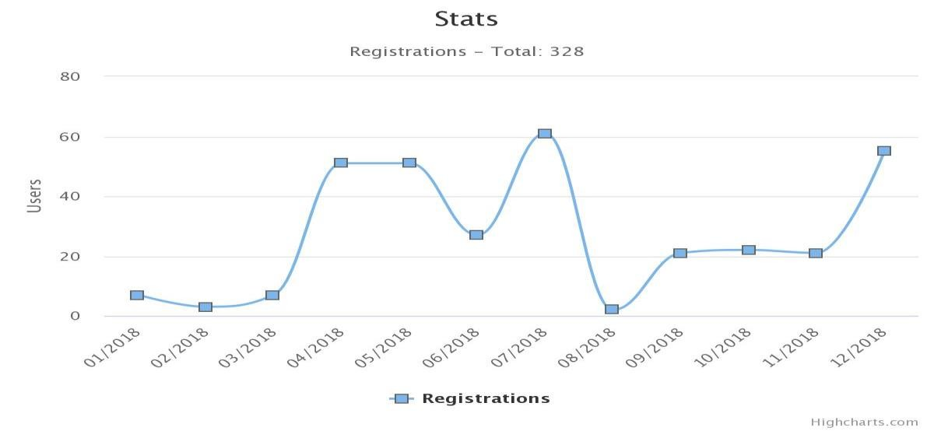
20

Number of registered users of Triagonal e-learning
350
300
250
200
150
100
50
0
328
144
77
135
2015 2016 2017 2018

Since 2015, altogether 701 persons have used the e-learning option; they belonged to the following categories and sports:

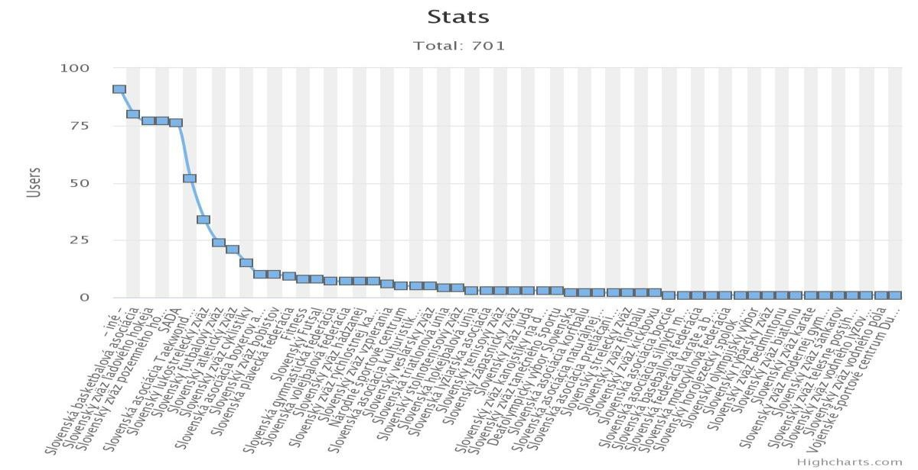

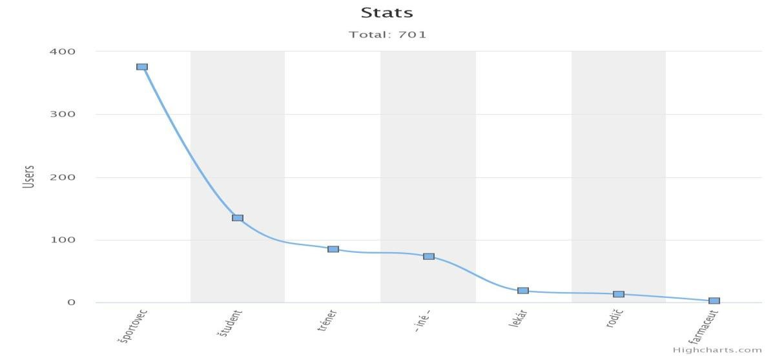
21

Assessment of the annual doping control plan for the
previous year
22

This part covers all activities related to both in-competition and out-of-competition sample collections. For 2018 the Agency planned to perform 300 doping controls. In 2018, SADA collected samples of biological materials based on its own plans which corresponded to WADA regulations and to TDSSA. In addition to its own plan, SADA provided full cooperation at the national and international level, including mainly preparation of doping controls and collecting samples at European and world sports events. However, international cooperation in doping controls does not
mean only SADA´s cooperation in sample collections in the Slovak Republic but also ordering testing of Slovak sportsmen abroad by a relevant anti-doping organisation.
The following sample collections were performed in 2018 under SADA´s authority:

- 318 urine sample collections (154 in-competition and 164 out-of-competition collections) in relation to which 80 additional EPO (ESA) analyses and 61 growth hormone factors (GHRFs) analyses were ordered;
- additional analyses were necessary for 14 urine samples in order to confirm the steroid profile (SPC);
- 114 blood sample collections (74 collections to identify the growth hormone and 40 collections necessary for establishing and maintaining blood passports);
- in addition to laboratory tests, 8 screening tests were conducted to identify social drugs in teams of ice hockey players.

SADA annually changes the proportion between in-competition
and out-of-competition sample collections according to the current need and according to cycles of most significant European and world sports events held.
In 2018, SADA performed the following sample collections ordered by different authorities:

- 186 urine samples (242 in 2017);
- 13 blood samples (48 in 2017).

97 missions had to be carried out in order to perform all sample collections in 2018. The shortest missions were accomplished in one day and the longest one took as many as 6 days, while 1 to 60 samples were collected in each of them.
9 cases of violations of anti-doping rules by sportsmen were concluded in 2018. 8 cases of violations concerned sportsmen registered in the Slovak Association of Fitness, Body-Building and Powerlifting. 6 cases were of an analytical and 2 cases were of a non-analytical nature. 1 case of violation of anti-doping rules was revealed at an event of the
Slovak Natural Body-Building Association and it was of an analytical nature.
In 2018, blood passports were introduced for all sportsmen included in NRTP who have 30% ESA or more according to TDSSA.

Annual Financial Statements
23

Annual Financial Statements - see the Annexes:
Annex 1 Balance sheet
Annex 2 Profit and loss statement
Annex 3 Notes

Balance sheet
X X
X
Úč ROPO SFOV 1 - 01

Profit and loss statement Notes

Úč ROPO SFOV 1 - 02

Financial statements:
x

- ordinary

- extraordinary

For the period

from

Month
01

Year
2018

Month
12

to

Year
2018

Company ID No
50 119 231
Name of the accounting entity
Antidopingová agentúra SR

Registered office of the accounting entity, Street and number
Hanulova 5/C

Postal code
City name

841 01 Bratislava

Telephone No.

E-mail address
Fax No.

Prepared on: | 18 January 2019
Signature of the accounting entity´s statutory body or of a member of its statutory body:

SADA revenues from other sources for ordered doping controls

Summary of revenues and expenditures
24

 | Budget 2015 |  | Budget 2016 |  | Budget 2017 |  | Budget 2018
 | approved | adjusted | approved | adjusted | approved | adjusted | approved | adjusted
Balance from the previous year SOURCE 131 | € 0 | € 4,409 | €0 | € 76,753 | € 0 | € 24,513 | €0 | € 53,029
SOURCE 111 | € 407,670 | €407,670 | € 410,773 | € 415,831 | € 415,831 | € 464,922 | € 463,726 | € 496,337
Balance from the previous year SOURCE 46 | € 0 | € 17,952 | € 0 | € 285 | € 0 | € 16,968 | €0 | € 10,013
Revenues from other sources SOURCE 46 | € 33,194 | € 27,750 | € 33,194 | € 72,311 | € 33,194 | € 63,834 | € 43,194 | € 71,625

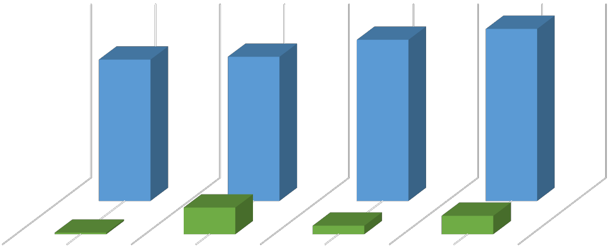
SADA´s revenues from the state budget

 | 2015 | 2016 | 2017 | 2018
SOURCE 131 | € 4,409 | € 76,753 | € 24,513 | € 53,029
SOURCE 111 | €407,670 | € 415,831 | € 464,922 | € 496,337

 | 2015 | 2016 | 2017 | 2018
SOURCE 46 | € 45,702 | € 72,596 | € 80,802 | € 81,637

Summary of revenues as of 31 December 2018 (€)
25
Economic classification item | Name | Approved budget | Adjusted budget | Actual amount as of 31 December  2018 | % of disbursement (approved budget) | % of disbursement (adjusted budget)
211 | Trading  income
212 | Property income
210 total
221 | Administrative fees
222 | Fines, penalties and other sanctions
223 | Fees and payments  from non-industrial and accidental sales and services | 43194 | 71625 | 71625 | 165.8 | 100.0
229 | Other administrative fees and other fees and payments
220 total |  | 43194 | 71625 | 71625 | 165.8 | 100.0
231 | Proceeds from the sales of capital assets
239 | Other capital revenues
230 total
242 | Interest on deposits
243 | Interest on financial management accounting
240 total
291 | Returned funds used without authorization or withheld funds
292 | Other revenues
290 total |  |  |  | 0
Non-tax revenues total /200/ |  | 43194 | 71625 | 71625 | 165.8 | 100.0
National common grants and transfers (310) |  | 463726 | 472337 | 472337 | 101.9 | 100.0
National capital grants and transfers (320) |  | 0 | 24000 | 24000 | 0.0 | 100.0
Grants and transfers total (300) |  | 463726 | 496337 | 496337 | 101.9 | 100.0
Balance of funds from the previous years source 46 (453) |  | 0 | 10013 | 10013 | 0.0 | 100.0
Balance of funds from the previous years source 131H (453) |  | 0 | 53029 | 53029 | 0.0 | 100.0
REVENUES TOTAL |  | 506920 | 631003 | 631003 | 133.8 | 100.0

26

Revenues with the source code 111 - Appropriations from the chapter
From the point of view of the valid budget classification, appropriations from the chapter reached EUR 496,337, representing 101.9% of the approved funds for 2018. In 2018, the above-stated amount of SADA´s revenues was provided continuously in monthly intervals from the total adjusted budget, increased by the amount of budgetary measures:
- funds in the amount of EUR 8,611 were released by a budgetary measure in accordance with Section 5 of the Act No. 333/2017 Coll. on the state budget for 2018, concluded higher-degree collective agreements for 2018, Ordinance of the Government of SR No. 359/2017 Coll., laying down the increased salary scales for employees providing public service by 4.8% from 1 January 2018.

- funds in the amount of EUR 24,000 for a capital expenditure intended for purchasing a passenger motor vehicle

Funds from other sources - source code 46
Actual disbursement of revenues of funds from other sources amounted to EUR 71,625 in 2018, representing 100% of the adjusted budget. It was related mainly to performance of doping controls.

Other revenues according to other source codes
In the monitored period SADA did not have any other revenues (according to other source codes) which would have any effect on the Agency´s activities.

Revenues from the sales of movable and immovable property
In the monitored period, SADA did not have any revenues from the sales of movable or immovable property.

SADA´s costs of doping control analyses

€ 141,005
€ 127,263
€ 101,136
€ 106,288
2015
2016
2017
2018

Disbursement of SADA´s expenditures in 2018
27

For 2018 SADA´s approved budget (hereinafter referred to as "ApB") amounted to EUR 506,920 and its adjusted budget (hereinafter referred to as "AdB") of total expenditures amounted to EUR 631,003. The amount of EUR 434,500 was disbursed during the monitored period without any funds from other sources (87.5% compared to AdB). Disbursement with funds from other sources amounted to EUR 562,708 (89.2% compared to AdB). In the monitored period, SADA did not have any funds from the EU budget or any foreign funds provided to the Slovak Republic or to SADA directly, including funds acquired through the Norwegian or Swiss financial mechanism.

Common expenditures in the 610 category – Wages, salaries, service income and other individual settlements
For 2018, SADA´s total expenditures in the 610 category in ApB amounted to EUR 153,443 and in AdB they amounted to EUR 177,706 (of which the source 111 amounted to EUR 132,943 in ApB and in AdB it amounted to EUR 139,324). The amount of EUR 127,699 was disbursed during the monitored period without any funds from other sources (91.7% compared to AdB). Disbursement with funds from other sources amounted to EUR 159,866 (90.0% compared to AdB).

Employment assessment
No employees were hired and one employee´s employment terminated in 2018. As of 31 December 2018 the actual number of SADA´s employees was adjusted to the total number of 9 employees, out of that 4 women. As of 31 December 2018 the company has no vacancy. The average salary per one SADA employee amounted to EUR 1,290 in 2018.

Common expenditures in the 620 category - Insurance premium and contributions to insurance companies
In the 620 category, SADA´s ApB amounted to EUR 46,464 and its AdB reached EUR 74,832. The amount of EUR 69,570 was disbursed in total in 2018 (93% compared to AdB). In the monitored period, wages for December 2017 in the 620 category were paid from the funds from other resources (131H source) in the amount of EUR 6,236 (100.0% compared to AdB) for contributions to the social and health insurance companies.

Common expenditures in the 630 category - Goods and services
SADA´s expenditures in the 630 category in ApB amounted to EUR 307,013 and in AdB they amounted to EUR 348,796 (of which the source 111 amounted to EUR 284,319 in ApB and in AdB it amounted to EUR 258,784). In the monitored period, expenditures without any funds from other sources were disbursed in the amount of EUR 237,798 (91.9% compared to AdB); together with funds from other sources an amount of EUR 327,603 was disbursed (93.9% compared to AdB). Disbursement in the 630 category according to source codes was as follows: EUR 237,798 from the 111 source, EUR 33,917 from the 131H source and EUR 55,889 from the 46 source.

Common expenditures in the 640 category - Common transfers
SADA did not have any expenditures in the 640 category in ApB, and in AdB they amounted to EUR 5,669. (out of that the 111 source in AdB amounted to EUR 5,669). Expenditures in the amount of EUR 5,669 were disbursed during the monitored period without any funds from other sources (100% compared to AdB). Funds were disbursed only from the 111 source: EUR 5,530 was used for the INADO membership fee and EUR 138 was used for sickness benefits. Disbursement with funds from other sources amounted to EUR 5,669 (100% compared to AdB).

Capital expenditures in the 710 category - Purchase of capital assets
SADA did not have any capital expenditures in the 710 category in ApB, and in AdB they amounted to EUR 24,000. Capital expenditures were not disbursed in 2018 and they will be used for purchasing a company motor vehicle in 2019.

Disbursement of expenditures as of 31 December 2018 (€)
28
(OS = funds from other sources)

Category/Item | Approved | Adjusted | Disbursement | %  disbursement | Disbursement | Disbursement | %  disbursement
 | budget | budget | without OS | in relation to AdB without OS | OS | with OS | in relation to AdB with OS
 | 2018
Total (600 + 700) | 506,920 | 631,003 | 434,500 | 87.5 | 128,209 | 562,708 | 89.2
600 - COMMON EXPENDITURES | 506,920 | 607,003 | 434,500 | 92.0 | 128,209 | 562,708 | 92.7
610 - Wages, salaries, service income and other individual settlements | 132,943 | 139,324 | 127,699 | 91.7 | 0 | 127,699 | 91.7
of which: | 91,730 | 100,116 | 91,877 | 91.8 | 0 | 91,877 | 91.8
611 - Grade-based salary, individual salary
612001 - Individual bonus | 39,773 | 37,733 | 34,503 | 91.4 | 0 | 34,503 | 91.4
612002 - Other bonuses | 1,440 | 1,475 | 1,319 | 89.4 | 0 | 1,319 | 89.4
620 - Insurance premium and contributions to insurance companies | 46,464 | 68,596 | 63,334 | 92.3 | 0 | 63,334 | 92.3
of which: | 8,200 | 13,350 | 12,347 | 92.5 | 0 | 12,347 | 92.5
621 - Insurance premium payable to VšZP
623 - Insurance premium payable to other health insurance companies | 4,014 | 5,085 | 4,664 | 91.7 | 0 | 4,664 | 91.7
625001 - For sickness insurance | 2,280 | 2,536 | 2,340 | 92.3 | 0 | 2,340 | 92.3
625002 - For old-age insurance | 18,330 | 26,077 | 24,075 | 92.3 | 0 | 24,075 | 92.3
625003 - For accident insurance | 1,770 | 1,489 | 1,375 | 92.3 | 0 | 1,375 | 92.3
625004 - For disability insurance | 3,650 | 5,452 | 5,034 | 92.3 | 0 | 5,034 | 92.3
625005 - For unemployment insurance | 1,560 | 1,811 | 1,672 | 92.3 | 0 | 1,672 | 92.3
625007 - For Solidarity Reserve Fund insurance | 6,660 | 8,847 | 8,168 | 92.3 | 0 | 8,168 | 92.3
627 - Insurance premium payable for complementary retirement savings | 0 | 3,949 | 3,659 | 92.7 | 0 | 3,659 | 92.7
630 - Goods and services | 284,319 | 258,748 | 237,798 | 91.9 | 0 | 237,798 | 91.5
of which: - 02605 Programme | 17,573 | 10,022 | 10,022 | 100.0 | 0 | 10,022 | 100.0
631001 - National
631002 - Foreign | 19,967 | 14,101 | 14,101 | 100.0 | 0 | 14,101 | 100.0
632001 - Energy | 799 | 0 | 0 | 0.0 | 0 | 0 | 0.0
632003 - Postal services | 10,384 | 5,709 | 5,709 | 100.0 | 0 | 5,709 | 100.0
632005 -  Telecommunication services | 0 | 3,551 | 3,551 | 100.0 | 0 | 3,551 | 100.0
633001 - Interior equipment | 1,981 | 0 | 0 | 0.0 | 0 | 0 | 0.0
633004 - Operating machinery and devices | 1,994 | 1,129 | 1,129 | 100.0 | 0 | 1,129 | 100.0

29

633005 - Special machinery and devices | 3,195 | 0 | 0 | 0.0 | 0 | 0 | 0.0
633006 - General material | 19,611 | 17,053 | 17,053 | 100.0 | 0 | 17,053 | 100.0
633009 - Books, magazines, newspaper | 3,195 | 557 | 557 | 100.0 | 0 | 557 | 100.0
633010 - Work clothing | 1,598 | 0 | 0 | 0.0 | 0 | 0 | 0.0
633011 - Food | 0 | 234 | 234 | 100.0 | 0 | 234 | 100.0
633016 - Representation | 799 | 332 | 332 | 100.0 | 0 | 332 | 100.0
634001 - Fuel, lubricants, oils | 5,080 | 1,180 | 1,180 | 100.0 | 0 | 1,180 | 100.0
634002 - Service, maintenance, repairs | 6,390 | 2,058 | 2,058 | 100.0 | 0 | 2,058 | 100.0
634003 - Insurance | 5,591 | 1,896 | 1,896 | 100.0 | 0 | 1,896 | 100.0
634005 - Cards, stamps, fees | 799 | 202 | 202 | 100.0 | 0 | 202 | 100.0
635001 - Of the interior equipment | 799 | 0 | 0 | 0.0 | 0 | 0 | 0.0
635004 - Of the operating machinery and devices | 2,591 | 0 | 0 | 0.0 | 0 | 0 | 0.0
637001 - Trainings, seminars, conferences | 10,000 | 17,562 | 17,562 | 100.0 | 0 | 17,562 | 100.0
637003 - Promotion and advertising | 0 | 1,776 | 1,776 | 100.0 | 0 | 1,776 | 100.0
637004 - General services | 33,530 | 17,051 | 15,148 | 88.8 | 0 | 15,148 | 88.8
637005 - Special services | 13,597 | 23,237 | 21,809 | 93.9 | 0 | 21,809 | 93.9
637006 - Compensation | 0 | 20 | 20 | 100.0 | 0 | 20 | 100.0
637007 - Travel allowances | 994 | 35 | 35 | 100.0 | 0 | 35 | 100.0
637011 - Studies, expertises, assessments | 73,986 | 73,986 | 60,740 | 82.1 | 0 | 60,740 | 82.1
637014 - Meals | 3,396 | 5,414 | 5,269 | 97.3 | 0 | 5,269 | 97.3
637016 - Contribution to the social fund | 979 | 2,091 | 1,938 | 92.7 | 0 | 1,938 | 92.7
637024 - Settlement of foreign exchange differences | 503 | 0 | 0 | 0.0 | 0 | 0 | 0.0
637027 - Remuneration for employees outside employment | 23,932 | 28,535 | 25,925 | 90.8 | 0 | 25,925 | 90.8
637030 - Advance payments | 0 | 0 | 0 | 0.0 | 0 | 0 | 0.0
637035 - Taxes | 56 | 111 | 111 | 100.0 | 0 | 111 | 100.0
637036 - Representation expenditures | 0 | 68 | 68 | 100.0 | 0 | 68 | 100.0
of which: - 0EK0F Programme | 5,000 | 1,645 | 1,645 | 100.0 | 0 | 1,645 | 100.0
633002 - Computer technology
633003 -  Telecommunication technology | 300 | 40 | 40 | 100.0 | 0 | 40 | 100.0
633013 - Software | 500 | 0 | 0 | 0.0 | 0 | 0 | 0.0
633018 - Licences | 700 | 97 | 97 | 100.0 | 0 | 97 | 100.0
635002 - of the computer technology | 500 | 0 | 0 | 0.0 | 0 | 0 | 0.0
635003 -  of the telecommunication technology | 500 | 0 | 0 | 0.0 | 0 | 0 | 0.0

30

637040 - ICT services | 13,000 | 28,558 | 27,309 | 95.6 | 0 | 27,309 | 95.6
632004 - Communication infrastructure | 500 | 500 | 282 | 56.4 | 0 | 282 | 56.4
640 - Common transfers | 0 | 5,669 | 5,669 | 100.0 | 0 | 5,669 | 100.0
of which: | 0 | 138 | 138 | 100.0 | 0 | 138 | 100.0
642015 - For sickness benefits
649003 - To an international organization | 0 | 5,530 | 5,530 | 100.0 | 0 | 5,530 | 100.0
610 - Wages, salaries, service income and other individual settlements SOURCE 131H | 0 | 12,876 | 0 | 0.0 | 12,876 | 12,876 | 100.0
of which: | 0 | 8,663 | 0 | 0.0 | 8,663 | 8,663 | 100.0
611 - Grade-based salary, individual salary
612001 - Individual bonus | 0 | 4,096 | 0 | 0.0 | 4,096 | 4,096 | 100.0
612002 - Other bonuses | 0 | 117 | 0 | 0.0 | 117 | 117 | 100.0
620 - Insurance premium and contributions to insurance companies  SOURCE 131H | 0 | 6,236 | 0 | 0.0 | 6,236 | 6,236 | 100.0
of which: | 0 | 1,102 | 0 | 0.0 | 1,102 | 1,102 | 100.0
621 - Insurance premium payable to VšZP
623 - Insurance premium payable to other health insurance companies | 0 | 647 | 0 | 0.0 | 647 | 647 | 100.0
625001 - For sickness insurance | 0 | 245 | 0 | 0.0 | 245 | 245 | 100.0
625002 - For old-age insurance | 0 | 2,536 | 0 | 0.0 | 2,536 | 2,536 | 100.0
625003 - For accident insurance | 0 | 145 | 0 | 0.0 | 145 | 145 | 100.0
625004 - For disability insurance | 0 | 525 | 0 | 0.0 | 525 | 525 | 100.0
625005 - For unemployment insurance | 0 | 175 | 0 | 0.0 | 175 | 175 | 100.0
625007 - For Solidarity Reserve Fund insurance | 0 | 861 | 0 | 0.0 | 861 | 861 | 100.0
630 - Goods and services - 02605 Programme SOURCE 131H | 0 | 33,917 | 0 | 0.0 | 33,917 | 33,917 | 100.0
of which: | 0 | 103 | 0 | 0.0 | 103 | 103 | 100.0
631002 - Foreign
632003 - Postal services | 0 | 296 | 0 | 0.0 | 296 | 296 | 100.0
632005 -  Telecommunication services | 0 | 820 | 0 | 0.0 | 820 | 820 | 100.0
634001 - Fuel, lubricants, oils, special liquids | 0 | 108 | 0 | 0.0 | 108 | 108 | 100.0
637005 - Special services | 0 | 3,151 | 0 | 0.0 | 3,151 | 3,151 | 100.0
637011 - Studies, expertises, assessments | 0 | 25,413 | 0 | 0.0 | 25,413 | 25,413 | 100.0
637015 - Insurance | 0 | 1,145 | 0 | 0.0 | 1,145 | 1,145 | 100.0

31

637016 - Contribution to the social fund | 0 | 199 | 0 | 0.0 | 199 | 199 | 100.0
637027 - Remuneration for employees outside employment | 0 | 2,682 | 0 | 0.0 | 2,682 | 2,682 | 100.0
610 - Wages, salaries, service income and other individual settlements SOURCE 46 | 20,500 | 25,506 | 0 | 0.0 | 19,291 | 19,291 | 75.6
of which: | 0 | 6 | 0 | 0.0 | 1 | 1 | 7.8
611 - Grade-based salary, individual salary
614 - Rewards | 20,500 | 25,500 | 0 | 0.0 | 19,291 | 19,291 | 75.7
630 - Goods and services  SOURCE 46 | 22,694 | 56,131 | 0 | 0.0 | 55,889 | 55,889 | 99.6
of which: | 0 | 0 | 0 | 0.0 | 0 | 0 | 0.0
631001 - National
631002 - Foreign | 0 | 0 | 0 | 0.0 | 0 | 0 | 0.0
632003 - Postal services | 0 | 490 | 0 | 0.0 | 490 | 490 | 100.0
632005 -  Telecommunication services | 0 | 0 | 0 | 0.0 | 0 | 0 | 0.0
633001 - Interior equipment | 3,000 | 0 | 0 | 0.0 | 0 | 0 | 0.0
633004 - Operating machinery, devices, equipment, technology and tools | 1,094 | 0 | 0 | 0.0 | 0 | 0 | 0.0
633006 - General material | 5,500 | 0 | 0 | 0.0 | 0 | 0 | 0.0
634002 - Service, maintenance, repairs | 400 | 0 | 0 | 0.0 | 0 | 0 | 0.0
637001 - Trainings, seminars, conferences | 1,000 | 8 | 0 | 0.0 | 8 | 8 | 100.0
637004 - General services | 3,500 | 0 | 0 | 0.0 | 0 | 0 | 0.0
637005 - Special services | 0 | 295 | 0 | 0.0 | 295 | 295 | 100.0
637011 - Studies, expertises, assessments | 6,500 | 54,852 | 0 | 0.0 | 54,852 | 54,852 | 100.0
637012 - Fees and levies | 500 | 425 | 0 | 0.0 | 183 | 183 | 43.1
637014 - Meals | 0 | 0 | 0 | 0.0 | 0 | 0 | 0.0
637031 - Fines and penalties | 1,200 | 60 | 0 | 0.0 | 60 | 60 | 100.0
637040 - ICT services | 0 | 0 | 0 | 0.0 | 0 | 0 | 0.0
700 - CAPITAL EXPENDITURE | 0 | 24,000 | 0 | 0.0 | 0 | 0 | 0.0
710 - Purchase of capital assets | 0 | 24,000 | 0 | 0.0 | 0 | 0 | 0.0
of which: | 0 | 24,000 | 0 | 0.0 | 0 | 0 | 0.0
714001 - Of passenger cars
720 - Capital transfers | 0 | 0 | 0 | 0.0 | 0 | 0 | 0.0

Prepared on:
32

15 April 2018

Prepared by:

Ing. Tomáš Pagáč, PhD.

Mgr. Ján Baník

Mgr. Soňa Haulišová

Viera Kolibášová

Mgr. Slavomíra Horváthová

MUDr. Ľubomír Gulán

Approved by:

PaedDr. Žaneta Csáderová, PhD.

